News from Israel
An evening with Leehee Rothschild
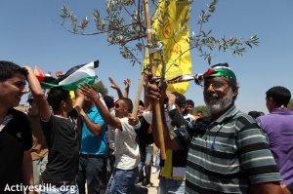

A rare opportunity, to hear from Leehee Rothschild – former occupation refuser, member of Boycott from Within and anti wall demonstrator - about the Boycott Israel movement inside Israel.
On Friday 9th September at 6.30pm at Holy Trinity Church, Boar Lane, Leeds centre.
Contact leedspsc@googlemail.com for more information.


