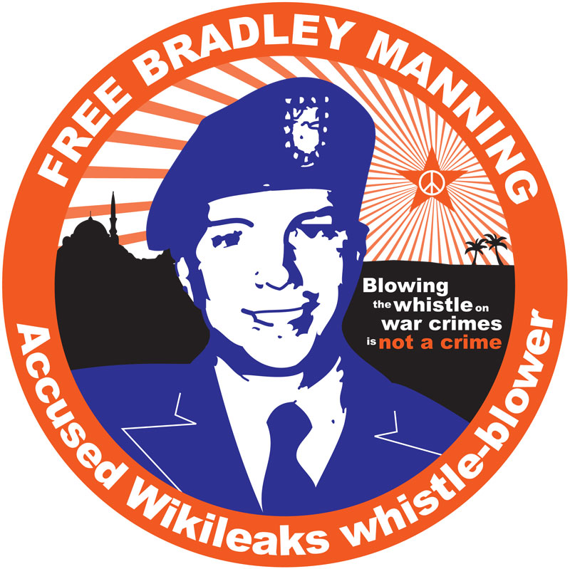
Prisoner Support Cafe
for Bradley Manning
Saturday 5th February
12pm - 4pm
At the 1in12 Club
Albion Street Bradford City Centre BD1 2LY
We'll be raising funds and awareness for Bradley Manning. He has been charged with "unauthorized disclosure of classified information" while serving in the US army. He's the guy who apparently leaked the 'Collateral Murder' video which clearly shows the unprovoked slaying of a wounded Reuters employee and his rescuers in the Iraqi suburb of New Baghdad by American armed forces. Two young children involved in the rescue were also seriously wounded.
There will be hot and cold food on sale, including meals and cakes. All Vegan.

