Palestine Solidarity Campaign
Public Meeting
Can Obama bring justice and peace to the Middle East
Professor Jeff Halper
Director (Israeli Committee Against House Demolition)
Friday 4th September 6.30 pm
Library Lecture Theatre, Tudor Square, (Behind the city Library Sheffield S1 1XZ) Sheffield

Certain individuals show real moral and physical courage in their commitment for the oppressed. Jeff Halper is such a man. Israel has illegally demolished 24,000 Palestinian houses since 1967. This is part of the ethnic cleansing of Palestinians, particularly around Jerusalem but also to make way for its Apartheid wall. Jeff is an Israeli Jew who is the Director of the Israeli Committee Against House Demolitions. This body of Israeli activists opposes the bulldozing of Palestinian homes. Israel is also engaged in the collective punishment of Gaza Palestinians. 1.5 million people are enclosed in a poverty stricken ghetto. Jeff was on one of the Free Gaza boats that broke the siege of Gaza. He was jailed for this when he returned home to Israel. He is currently out on bail.
He has been awarded Palestinian citizenship and has won various honours including the Kant-World-Citizen-Prize for 2009 and Rachel Corrie Peace Award.
His books include, An Israeli in Palestine: Resisting dispossession, redeeming Israel (Pluto Press, London, 2008) and Obstacles to Peace (ICAHD, 2009). In them argues for the end of the Occupation and a just and sustainable solution to the Israeli-Palestinian conflict based on a respect for international law and universal human rights.
We are extremely fortunate to have Jeff come to Sheffield to talk to us.
Please come to the meeting, bring your friends.

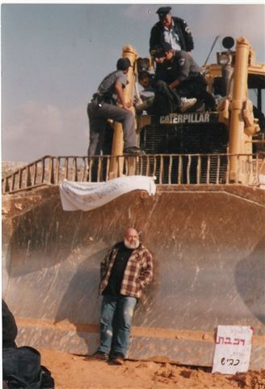
Jeff Halper blocking the
path of a bulldozer

Palestine Solidarity Campaign
Public Meeting
Can Obama bring justice and peace to the Middle East
Professor Jeff Halper
Director (Israeli Committee Against House Demolition)
Friday 4th September 6.30 pm
Library Lecture Theatre, Tudor Square, (Behind the city Library Sheffield S1 1XZ) Sheffield

Jeff Halper blocking the
path of a bulldozer

Palestine Solidarity Campaign
Public Meeting
Can Obama bring justice and peace to the Middle East
Professor Jeff Halper
Director (Israeli Committee Against House Demolition)
Friday 4th September 6.30 pm
Library Lecture Theatre, Tudor Square, (Behind the city Library Sheffield S1 1XZ) Sheffield

Palestine Solidarity Campaign
Public Meeting
Can Obama bring justice and peace to the Middle East
Professor Jeff Halper
Director (Israeli Committee Against House Demolition)
Friday 4th September 6.30 pm
Library Lecture Theatre, Tudor Square, (Behind the city Library Sheffield S1 1XZ) Sheffield
Certain individuals show real moral and physical courage in their commitment for the oppressed. Jeff Halper is such a man. Israel has illegally demolished 24,000 Palestinian houses since 1967. This is part of the ethnic cleansing of Palestinians, particularly around Jerusalem but also to make way for its Apartheid wall. Jeff is an Israeli Jew who is the Director of the Israeli Committee Against House Demolitions. This body of Israeli activists opposes the bulldozing of Palestinian homes. Israel is also engaged in the collective punishment of Gaza Palestinians. 1.5 million people are enclosed in a poverty stricken ghetto. Jeff was on one of the Free Gaza boats that broke the siege of Gaza. He was jailed for this when he returned home to Israel. He is currently out on bail.
He has been awarded Palestinian citizenship and has won various honours including the Kant-World-Citizen-Prize for 2009 and Rachel Corrie Peace Award.
His books include, An Israeli in Palestine: Resisting dispossession, redeeming Israel (Pluto Press, London, 2008) and Obstacles to Peace (ICAHD, 2009). In them argues for the end of the Occupation and a just and sustainable solution to the Israeli-Palestinian conflict based on a respect for international law and universal human rights.
We are extremely fortunate to have Jeff come to Sheffield to talk to us.
Please come to the meeting, bring your friends.
Palestine Solidarity Campaign
Public Meeting

