
Sheffield Palestine Solidarity Campaign
www.sheffieldpsc.org.uk
Jeff blocking the path of an Israeli bulldozer

Public Meeting
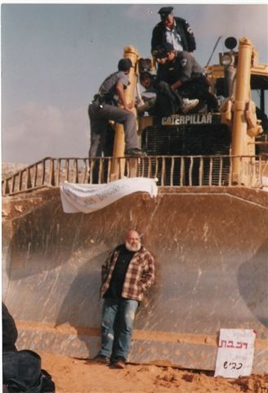
An Israeli in Palestine: Resisting dispossession Professor Jeff Halper
Director Israeli Committee Against House Demolition (ICAHD)

Friday 4th September 6:30 pm
Library Lecture Theatre, Tudor Square, (Behind the city Library Sheffield S1 1XZ) - Contact 0771 5048821 for more details

Sheffield Palestine Solidarity Campaign
www.sheffieldpsc.org.uk

Public Meeting

An Israeli in Palestine: Resisting dispossession Professor Jeff Halper

Director - Israeli Committee Against House Demolition (ICAHD)

Certain individuals show real moral and physical courage in their commitment for the oppressed. Jeff Halper is such a man. Israel has illegally demolished more than 24,000 Palestinian houses since 1967. This is part of the ethnic cleansing of Palestinians, particularly around Jerusalem but also to make way for its Apartheid wall.

Jeff is an Israeli Jew and the Director of the Israeli Committee Against House Demolitions. Israel is also engaged in the collective punishment of Gaza Palestinians where 1.5 million people are enclosed in a poverty stricken ghetto. Jeff was on the first of the Free Gaza boats that broke the siege of Gaza. He was jailed for this when he returned home to Israel and is currently out on bail. He has been awarded Palestinian citizenship and has won various honours including the Kant-World-Citizen-Prize for 2009 and the Rachel Corrie Peace Award and was a 2006 nominee for the Nobel Peace Prize.

His books include, An Israeli in Palestine: Resisting dispossession, redeeming Israel (Pluto Press, London, 2008) and Obstacles to Peace (ICAHD, 2009).

Friday 4th September 6:30 pm
Library Lecture Theatre, Tudor Square, (Behind the city Library Sheffield S1 1XZ)

Please come along and bring your friends
A collection will be taken for ICAHD's work in Jerusalem
Contact 0771 5048821 for more details

